VASAVI COLLEGE OF ENGINEERING (AUTONOMOUS)
IBRAHIMBAGH, HYDERABAD-31
Department of Computer Science and Engineering

Name of the Course: Design & Analysis of Algorithms
Assignment – 2

Name of the Faculty: Dr.M.Sunitha Reddy Date of submission: 20/04/2023
Class: B.E 2/4 A Sem: IV

Set-1 (1602-21-733-012, 013, 015, 020, 026, 029, 032, 036, 037, 069)

Q.no | Question | Marks | BTL (1/2/3/4/5/6) | Course Outcome | PO
1 | Marc loves cupcakes, but he also likes to stay fit. He eats n cupcakes in one sitting, and each cupcake i has a calorie count c[i] . After eating a cupcake with c calories, he must walk at least 2^j * c (where j is the number cupcakes he has already eaten) miles to maintain his weight.  Given the individual calorie counts for each of the cupcakes, find and print a long integer denoting the minimum number of miles Marc must walk . maintain his weight. Note that he can eat the cupcakes in any order.  Notes: Has to be done greedily so that you have to burn as less calories as possible  Input Format  The first line contains an integer, N , denoting the number of cupcakes. The second line contains N space-separated integers describing the respective calorie counts of each cupcake,c[1]...c[n].  Constraints  1<=n<=40 1<=ci<=1000  Output Format  Print a long integer denoting the minimum number of miles Marc must walk to maintain his weight.  Sample Input  3  1 3 2  Sample Output  11  Also analyze the time complexity of the designed solution. | 2 | 3 | 2 | 1,2,3
2 | A networking company uses a compression technique (Huffman coding) to encode the message before transmitting over the network. Suppose the message contains the following characters with their frequency, obtain an optimal solution to encode the message and compute the average length of the code. Character frequency given as  Implement the algorithm for a given input. Also analyze the time complexity of the designed solution. | 1 | 3 | 2 | 1,2,3
  M1 | M2 | M3 | M4 | M5 | M6
  12 | 5 | 8 | 14 | 44 | 18
3 | Obtain the optimal binary search tree with equal probabilities for the identifier set (a1, a2, a3) = ( if, stop, while) | 1 | 3 | 3 | 1,2,3
4 | 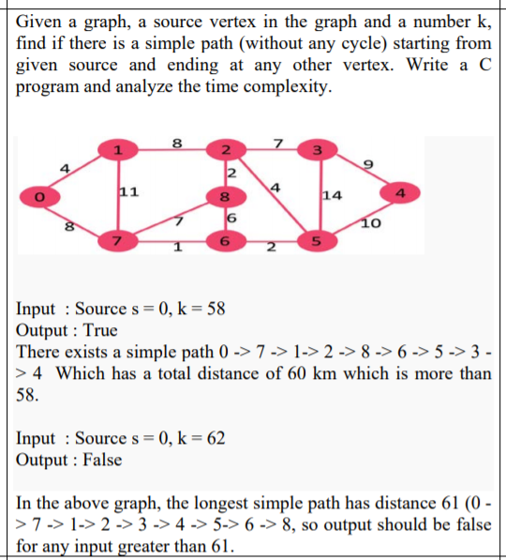 | 1 | 3 | 3 | 1,2,3

Set-2 (1602-21-733-001, 002,003,004,005,006,007,008)
Q.no | Question | Marks | BTL (1/2/3/4/5/6) | Course Outcome | PO
1 | A Research and Development Labs has proposed a new divide-and-conquer algorithm for computing minimum spanning trees, which goes as follows. Given a graph G(V, E) with distinct costs on its edges, partition the set V of vertices into two sets V1 and V2 such that V1 and V2 differ by at most 1. Let E1 be the set of edges that are incident only on vertices in V1, and let E2 be the set of edges that are incident only on vertices in V2. Recursively solve a minimum-spanning-tree problem on each of the two sub graphs G1(V1, E1) and G2(V2, E2). Finally, select the minimum-weight edge in E that crosses the cut (V1, V2) and use this edge to unite the resulting two minimum spanning trees into a single spanning tree.  Either argue that the algorithm correctly computes a minimum spanning tree of G(V, E), or provide an example for which the algorithm fails. | 2 | 3 | 2 | 1,2,3
2 | Vasya's sister loves arrays that are sorted in non - increasing order. Today is her birthday. Vasya wants to gift her sister sorted arrays on her birthday. But the shop has only unsorted arrays. So, Vasya bought T unsorted arrays and is trying to sort them. But, she doesn't have much time to sort the arrays manually as she is getting late for the birthday party. So, she asked you to write a program to sort the T arrays in non -increasing order. Help her, or her sister will be upset.  Formally, given T arrays as input, sort each one of them in non -increasing order and print each array in a new line.  INPUT  First line contains an integer T(1 <= T <= 100), denoting the number of test cases. First line of each test case contains an integer N(1 <= N <= 100000), denoting the size of the array. Second line contains N space separated integers, denoting the array elements Ai(1 <= Ai <= 1000000000).  OUTPUT For each test case, print the sorted array in non -increasing order.  Sample Input  2  5  2 5 2 4 3  5  5 4 2 3 1  Sample Output  5 4 3 2 2  5 4 3 2 1  Also analyze the time complexity of the designed solution. | 1 | 3 | 2 | 1,2,3
3 | Find the shortest path for a travelling sales person starting at vertex 1.  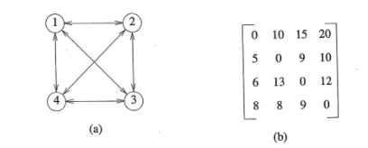 | 1 | 3 | 3 | 1,2,3
4 | Consider the following two sequence X and Y. Find the Longest Common Subsequence of X and Y.  X: ABCBDAB  Y: BDCABA | 1 | 3 | 3 | 1,2,3

Set-3 (1602-21-733-009, 010,011,014,016,017,018,019)

Q.no | Question | Marks | BTL (1/2/3/4/5/6) | Course Outcome | PO
1 | There are infinite number of coins of n different values. These values are given. Using these coins, you have to make change for Rs. Sum. Write an algorithm to Find the minimum number of coins required to change Rs. Sum.  Note that the problem is different from coin change problem. In coin change problem, we were asked to find out in how many ways the change can be made. In this problem, we are supposed to find out the minimum number of coins required to change.  Sum=11  n=4  coin[]={1,5,6,8}  Expected result=2  using 5 and 6  Analyze the time complexity of the designed algorithm | 2 | 3 | 2 | 1,2,3
2 | Suppose we are given a set of tasks specified by pairs of the start times and finish times as.  T={(1,2)(1,3)(1,4)(2,5)(3,7)(4,9)(5,6)(6,8)(7,9)}  Solve the task scheduling problem for this set of tasks. Implement the solution for any given input. Also analyze the time complexity of the designed solution. | 1 | 3 | 2 | 1,2,3
3 | Your task will be to calculate number of different assignments of n different topics to n students such that everybody gets exactly one topic he likes.  First line of input contains number of students n.  Each of the next n lines contains n integers describing preferences of one student. 1 at the ith position means that this student likes ith topic, 0 means that he definitely doesn’t want to take it.  No. of students = 3  preference matrix = 1 1 1  1 1 1  1 1 1  Expected result= 6 | 1 | 3 | 3 | 1,2,3
4 | Find nth Fibonacci number by using Dynamic programming algorithm. Analyse the time complexity.  The Fibonacci Sequence is the series of numbers: 0, 1, 1, 2, 3, 5, 8, 13, 21, 34, …  The next number is found by adding up the two numbers before it.  Let F[i] be the ith fibonacci number  F[0]=0  F[1]=1  F[i]=F[i-1]+F[i-2] | 1 | 3 | 3 | 1,2,3

Set-4 (1602-21-733-020,021,022,023,024,025,027,028)
Q.no | Question | Marks | BTL (1/2/3/4/5/6) | Course Outcome | PO
1 | There are two strings src and dest. The goal of the problem is to design and implement an algorithm that convert src to dest by applying minimum edit operations on string str1. The edit operations are following –  1) insert a character  2) delete a character  3) replace a character  Analyze the time complexity of the designed algorithm | 2 | 3 | 2 | 1,2,3
2 | Construct a minimum cost spanning tree using Kruskal’s Algorithm. Design the algorithm and analyze the time complexity. Implement the algorithm assuming weights as integers. Also analyze the time complexity of the designed solution.  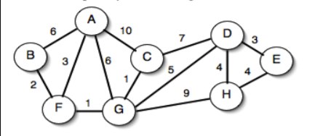 | 1 | 3 | 2 | 1,2,3
3 | Implement an algorithm for the given weights and values of n items, put these items in a knapsack of capacity M to get the maximum total value in the knapsack.  Note that, you can select items, the sum of whose weight is less than or equal to the capacity of knapsack, W.  Sample Input/ Output  number of items, n=4  weight of items, w[]=2 3 4 5  value of items, v[]=3 4 5 6  capacity of knapsack, M=5  maximum attainable value of items=7  by collecting first and second item in the knapsack | 1 | 3 | 3 | 1,2,3
4 | There are two assembly lines. Each assembly line has n stations.  Every station has some dedicated job that needs to done. For a station number i, you can get the job done on station number i of any assembly line.  You can go to station i only when you have been through station i-1.  From a station i, you can either go to the next station on the same line or you can transfer assebly line.  Information provided –  time to enter station 1 on both assembly lines  time to exit last station on both lines  job processing time for every station  The time to transfer from each station of assembly line 1 to next station of assembly line 2 is given  The time to transfer from each station of assembly line 2 to next station of assembly line 1  Objective of the problem is to finish all the jobs in minimum time.  Sample Input/ Output  No. of stations - 3  Entry time for station 1 on assebly lines 1 and 2 respectively - 3,1  Exit time from last station on assebly lines 1 and 2 respectively - 3,3  processing time for stations on assembly line 1 - 8, 4, 6  processing time for stations on assembly line 2 - 5, 7, 5  transfer times from a station on assebly line 1 to next station on assembly line 2 - 2, 2  transfer times from a station on assebly line 2 to next station on assembly line 1 - 1, 3  Minimum time to get all the jobs done is - 20 (1+5+1+4+6+3) | 1 | 3 | 3 | 1,2,3

Set-5 (1602-21-733-030,031,032,033,034,035,038,039)
Q.no | Question | Marks | BTL (1/2/3/4/5/6) | Course Outcome | PO
1 | Use optimal binary merge pattern for frequencies of characters in a document. Find the Huffman codes for each character  34,2,4,15,10,25,18,20  Implement the solution to the problem for a given set of inputs. Also analyze the time complexity of the designed solution | 2 | 3 | 2 | 1,2,3
2 | Construct a minimum cost spanning tree using Baruvka’s Algorithm. Design the algorithm and analyze the time complexity.  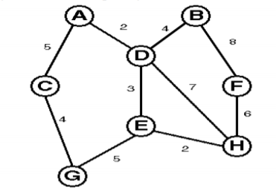 | 1 | 3 | 2 | 1,2,3
3 | There are n houses built in a line, each of which contain some value in it. A thief is going to steal in these houses. But he cannot steal in two adjacent houses. What is maximum value he can steal? Design and implement an algorithm to complete the task.  Maximum stolen value from first i houses of the line can be either the maximum stolen value from first i-1 houses of the line or maximum stolen value from i-2 houses of the line plus value in ith house. So, we will choose maximum of these. We will calculate the values in bottom up manner.  Expected Input and Output  number of houses=7  values[]=9, 3, 5, 8, 2, 4, 7  maximum stolen value=24 by stealing from first, fourth and seventh house | 1 | 3 | 3 | 1,2,3
4 | Given a rod of size n and values of various sizes of rod. Design an algorithm to cut the rod in such a way that the sum of values of the pieces is maximum.  The problem can be solved by calculating the maximum attainable value of rod by cutting in various pieces in a bottom up fashion by first calculating for smaller value of n and then using these values to calculate higher values of n.  Expected Input and Output  n=5  value[]= 2 3 7 8 10 for sizes 1,2,3,4,5 respectively  Expected result=11 by cutting the rod in pieces of sizes 1,1 and 3 | 1 | 3 | 3 | 1,2,3

Set-6 (1602-21-733-040 to 047)
Q.no | Question | Marks | BTL (1/2/3/4/5/6) | Course Outcome | PO
1 | Construct minimum cost spanning tree using Prim’s Algorithm. Design the algorithm and analyze the time complexity. Implement the algorithm for the given graph as input. Also analyze the time complexity of the designed solution.  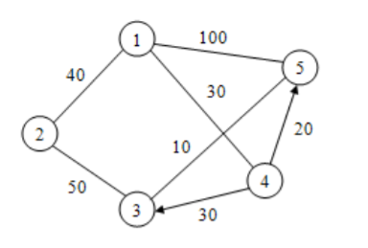 | 2 | 3 | 2 | 1,2,3
2 | You are given a sorted (from smallest to largest) array of distinct integers A[1], …A[n], which can be positive, negative, or zero. You want to decide whether or not there is an index i belongs to {1,2…n} such that A[i] = i. Design the fastest algorithm that you can for solving this problem. Design the algorithm and provide a formal analysis of its running time. Also implement the algorithm for any given input. | 1 | 3 | 2 | 1,2,3
3 | Given order of n matrices, Design an algorithm to find the minimum multiplication operations required for multiply n matrices.  Required condition for multiplying two matrices  If we have two matrix A of order a*b and matrix B of order c*d. In the product A*B, matrix A is called pre-multiplier and B is called the post-multiplier. A and B can be multiplied if b=c. And the order of the resulting matrix will be a*d.  In general, the number of columns of pre-multiplier matrix should be equal to number of rows of post-multiplier matrix.  Multiplication operations performed for multiplying two matrices  In the above example, the number of multiplication operations required for multiplying matrix A and B, will be a*b*d.  Now, suppose we have three matrices as follows –  matrix A of order a*b  matrix B of order b*c  matrix C of order c*d  We have to find the product A*B*C. This can be done in two ways mentioned below –  ((A*B)*C) – first multiplying A and B and then multiplying the resulting matrix with c  This will cost a*b*c + a*c*d multiplication operations  Also find the minimum number of multiplication operations required for the example given below. a=3, b=9, c=7, d=2 | 1 | 3 | 3 | 1,2,3
4 | Alex doesn’t like boredom. That’s why whenever he gets bored, he comes up with games. One long winter evening he came up with a game and decided to play it.  Given a sequence a consisting of n integers. The player can make several steps. In a single step he can choose an element of the sequence (let’s denote it a[k]) and delete it, at that all elements equal to a[k] + 1 and a[k] - 1 also must be deleted from the sequence. That step brings ak points to the player.  Alex is a perfectionist, so he decided to get as many points as possible. Help him.  Design and Analyse an algorithm to find the maximum points that can be collected with the given constraints. This can be solved with Dynamic Programming. First, we read all the values and group them.  For example – If the values are 2 1 3 4 2 3 4, we group all 1’s together, all 2’s together and so on. This way we will be able to find frequency of each number. | 1 | 3 | 3 | 1,2,3

Set-7 (1602-21-733-048 to 055)
Q.no | Question | Marks | BTL (1/2/3/4/5/6) | Course Outcome | PO
1 | Coins in the United States are minted with denominations of {1, 5, 10, 25, 50} cents. There are several ways to make change of any given amount of money: for example, to make change of 11 cents, we could use a dime and a penny, two nickels and a penny, or 11 pennies.  In the mythical country of CS161-land, coins are minted with denominations of {d1,…, dt} CS161- cents, where d1,…,dt are positive integers. In this problem, design algorithms to understand how to make change of n CS161-cents.  (a) Suppose that the denominations are {1, 6, 10}. What is the way to make change of 18 CS161-cents that involves the fewest coins? How many different ways are there to make change of 18 CS161-cents?  (b) Suppose that M[k] is the minimum number of coins needed to represent k CS161-cents. Give an efficient algorithm which maintains a table M, and which takes an integer n and a set D of denominations as input, and outputs a way to make change of n CS161-cents using the minimal number of coins. (Not just the number of coins needed).  (c) Analyze the running time of your algorithm in part (b). [We are expecting: The best big-oh running time you can guarantee, and a short justification.] | 2 | 3 | 2 | 1,2,3
2 | Construct a minimum cost spanning tree using Prim Jarnik Algorithm. Design the algorithm and analyze the time complexity.  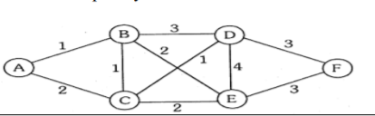 | 1 | 3 | 2 | 1,2,3
3 | You are given a matrix of order n*m. Each cell of the matrix has a gift of certain value. Starting from the top-left cell, you have to reach the bottom-right cell of the matrix collecting gifts of the visited cells. But you can visit either the cell below the current cell or the cell to right of current cell. Design and implement an algorithm to determine the maximum value of gifts you can collect. Analyze the time complexity of the designed algorithm.  Expected Input and Output  rows,columns=(4,4)  Values of gifts in cells  1 10 3 8  12 2 9 6  5 7 4 11  3 7 16 5  maximum attainable value of gifts=53 | 1 | 3 | 3 | 1,2,3
4 | Design an algorithm to find the longest repeating subsequence of a given string by using Dynamic programming. Consider the example given below:  A T A C T C G G A  A T A C T C G G A  The length of the longest repeating subsequence is 4  The longest repeating subsequence is ATCG  Analyze the time complexity of the designed algorithm. | 1 | 3 | 3 | 1,2,3

Set-8 (1602-21-733-056 to 062,064)
Q.no | Question | Marks | BTL (1/2/3/4/5/6) | Course Outcome | PO
1 | Consider the single machine scheduling problem where we are given a set T of tasks specified by their start times and finish times, as in the task scheduling problem, except now we have only one machine and we wish to maximize the number of tasks that this single machine performs. Design a greedy algorithm for this single machine scheduling problem and show that it is correct. What is the running time of this algorithm?. Implement the solution to the problem for any given set of input | 2 | 3 | 2 | 1,2,3
2 | Find an optimal placement for 13 programs on three tapes T0,T1 and T2, where the programs are of length 12,5,8,32,7,5,18,26,4,3,11,10 and 6. Design the algorithm and analyze the time complexity. Also, Implement the algorithm for any given input | 1 | 3 | 2 | 1,2,3
3 | There is a river. There are n cities on both sides of the river (not necessarily in the same order). Bridges are to be built on the river for every city (from one end of the river to the other end where the same city is located). But no two bridges should intersect. Find out the maximum number of cities for which the bridges can be built over the river. Design an algorithm with best time complexity possible.  Expected Input and Output  There are 4 cities.  The cities on first end of the river are in order 4 1 3 2  The cities on other end of the river are in order 1 3 4 2  First, we reorder the numbering of cities based on ordering of the other end  first end after reordering 3 1 2 4  other end after reordering 1 2 3 4 | 1 | 3 | 3 | 1,2,3
4 | How many structurally different binary trees are possible with n nodes? Justify your answer. | 1 | 3 | 3 | 1,2,3

Set-9 (1602-21-733-065,066,067,135,136 ,301)

Q.no | Question | Marks | BTL (1/2/3/4/5/6) | Course Outcome | PO
1 | Solve the following instance for the job sequencing with deadlines and find maximum profit, valid schedule, list of unfinished jobs. Implement the solution for any given input. Also analyze the time complexity of the designed solution | 2 | 3 | 2 | 1,2,3
  J | J1 | J2 | J3 | J4 | J5 | J6 | J7
  P | 3 | 5 | 20 | 18 | 1 | 6 | 30
  D | 1 | 3 | 4 | 3 | 2 | 1 | 2
2 | You have n = 3k coins (k >= 1) and a pan balance. One of the coins is counterfeit and it is lighter (in weight) than the rest. All the other (n-1) coins have the same weight. Design a divide and conquer algorithm to find the counterfeit coin in at most k rounds. In each round, you may put any number of coins in each pan of the balance, and, it tells you either that both sides have the same weight, or which side is heavier. Explain why your algorithm is correct, and justify the running time. | 1 | 3 | 2 | 1,2,3
3 | Ramu was a lazy farmer. He had inherited a fairly large farm and a nice house from his father. Ramu leased out the farm land to others and earned a rather handsome income. His father used to keep a buffalo at home and sell its milk but the buffalo died a few days after his father did.  Ramu too wanted to make some money from buffaloes, but in a quite a different way. He decided that his future lay in speculating on buffaloes. In the market in his village, buffaloes were bought and sold everyday. The price fluctuated over the year, but on any single day the price was always the same.  He decided that he would buy buffaloes when the price was low and sell them when the price was high and, in the process, accummulate great wealth. Unfortunately his house had space for just one buffalo and so he could own at most one buffalo at any time.  Before he entered the buffalo market, he decided to examine to examine the variation in the price of buffaloes over the last few days and determine the maximum profit he could have made. Suppose, the price of a buffalo over the last 10 days varied as 10 12 8 11 11 10 12 15 13 10  Ramu is a lazy fellow and he reckoned that he would have been willing to visit the market at most 5 times (each time to either buy or sell a buffalo) over the last 10 days. Given this, the maximum profit he could have made is 9 rupees. To achieve this, he buys a buffalo on day 1, sells it on day 2, buys one more on day 3 and sells it on day 8. If he was a little less lazy and was willing to visit the market 6 times, then he could have made more money. He could have bought on day 1, sold on day 2, bought on day 3, sold on day 4, bought on day 6 and sold on day 8 to make a profit of 10 rupees.  Your task is help Ramu calculate the maximum amount he can earn by speculating on buffaloes, given a history of daily buffalo prices over a period and a limit on how many times Ramu is  willing to go to the market during this period.  Input format  The first line of the input contains two integers N and K, where N is the number of days for which the price data is available and K is the maximum number of times that Ramu is willing to visit the cattle market. The next N lines (line 2, 3,...,N+1) contain a single positive integer each. The integer on line i+1, 1 ≤ i ≤ N, indicates the price of a buffalo on day i. Write a C program and analyze the time complexity.  Output format  A single nonnegative integer indicating that maximum amount of profit that Ramu can make if he were to make at most K trips to the market.  Test Data: You may assume that N ≤ 400 and K ≤ 400. Example: Here are sample inputs and outputs corresponding to the example discussed above.  Sample Input 1:  10  5  10  12  8  11  11  10  12  15  13  10  Sample Output 1:  9 | 1 | 3 | 3 | 1,2,3
4 | There are n identical dices. Each dice has given number of faces. In how many ways, you can get the given sum.  Create a matrix to store results and start calculating the results in a bottom up fashion.  Expected Input and Output  Case-1:  n=2  sum=4  faces=3  No. of ways=3 (1+3,2+2,3+1) | 1 | 3 | 3 | 1,2,3

Set-10 (1602-21-733-302 to 307)

Q.no | Question | Marks | BTL (1/2/3/4/5/6) | Course Outcome | PO
1 | You are given an empty bag that is supposed to be filled with gold, and it can carry at max W kgs of gold in it. You are given N samples of gold, with the ith of them weighing Wi and having value Vi.  Your task is to fill the bag with exactly W kgs of gold such that the total value of the gold inside the bag is maximum. You need not take the entire samples of gold, you can break them down and take fractions of those samples as well.  For example, if you have two samples, one with weight 10 and value 10 and another with weight 5 and value 10, you can fill a 5 kg capacity bag with 2.5 kg of first sample and 2.5 kg of second sample. The value for such a bag will be the sum of values of all the pieces, i.e. for the first sample 2.5 kg has value 2.5 and for the second sample 2.5 kg has value 5, hence the total value of the bag becomes 7.5.  INPUT  First line contains two integers, N and W. Second onwards, there are N lines with each of them containing two integers, first one being the weight of the sample and the second one being the value of the sample  OUTPUT Print one number, the maximum attainable value when the bag is filled with W kgs of gold. If it is not possible to fill the bag with W kgs of gold, print -1. CONSTRAINTS  1 ≤ N ≤ 105 1 ≤ W ≤ 109 1 ≤ weights, values ≤ 109 Sample Input 0 3 10 5 5 3 10 4 4 Sample Output 0 17.000000000000  Explanation  We can take 3 kgs of sample 2, 4 kgs of sample 1 and 3 kgs of sample 3 to attain the maximum value.  Also analyze the time complexity of the designed solution | 2 | 3 | 2 | 1,2,3
2 | Apply Bellman-Ford algorithm to find shortest path from 1 to the remaining vertices in the graph given below.  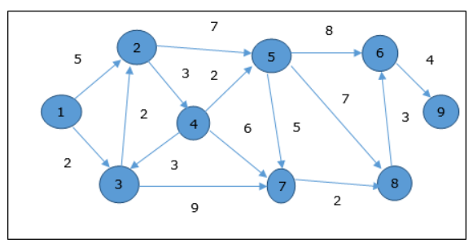 | 1 | 3 | 2 | 1,2,3
3 | Given an array of integers where each element represents the max number of steps that can be made forward from that element. Write an algorithm to find the minimum number of jumps to reach the end of the array (starting from the first element). If an element is 0, then cannot move through that element.  Expected Input and Output  Case-1:  jump values=2 8 3 6 9 3 0 0 1 3  Minimum number of jumps required to reach end is 2 (2->8->3) | 1 | 3 | 3 | 1,2,3
4 | You are given a string str. Find the length of longest palindromic subsequence in the given string using dynamic programming.  Expected Input and Output  Case-1:  str= ADBDCA  result = 5 (ADBDA) | 1 | 3 | 3 | 1,2,3

